- \Operation\Tube filling\Blow-off filling
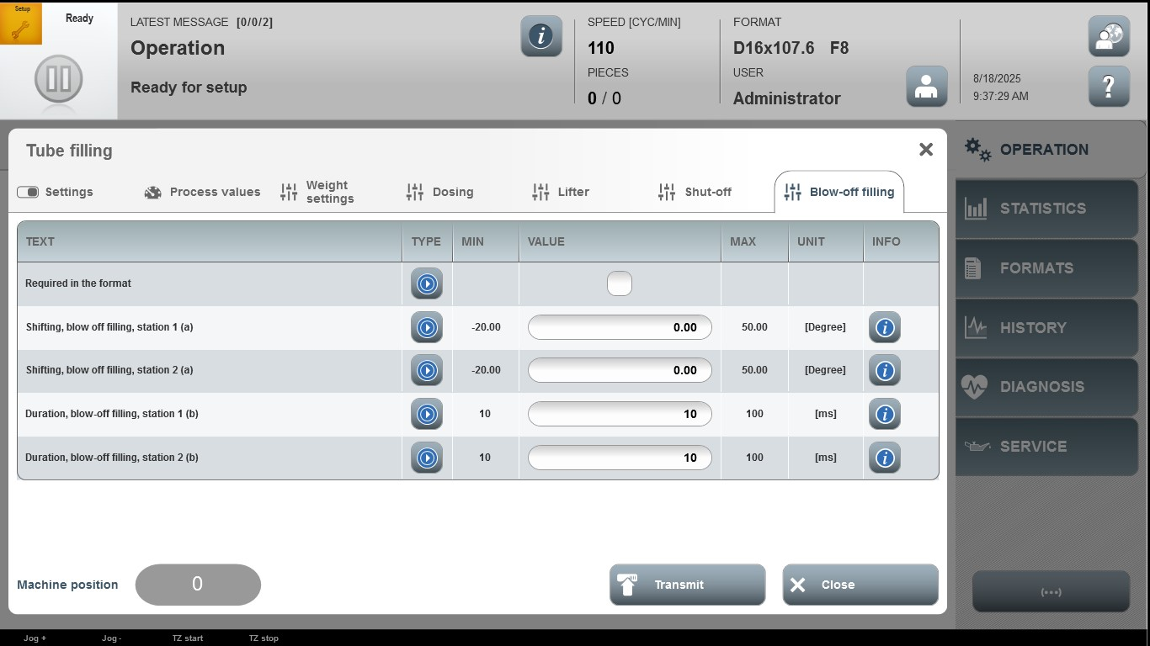

Acceptance criterion | Limits | Pass / Fail: Dev-No. | Date | Initials
Screen matches screenshot | N / A
Shifting, blow off filling, station 1 (a) | -20.00…50.00
Shifting, blow off filling, station 2 (a) | -20.00…50.00
Duration, blow-off filling,  station 1 (b) | 10…100
Duration, blow-off filling,  station 2 (b) | 10…100

